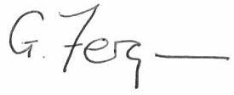 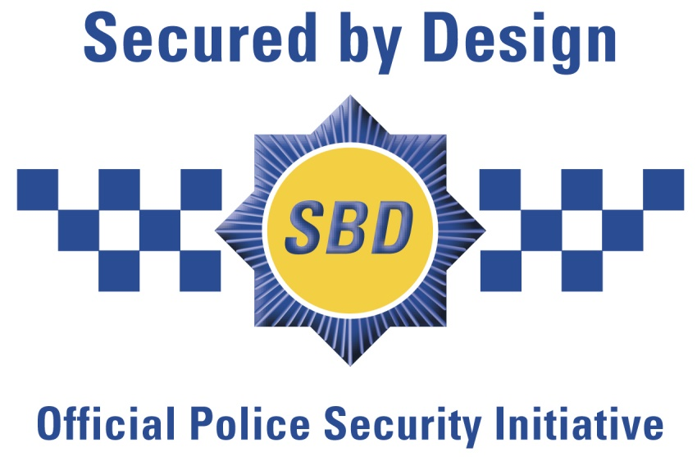­­

## This is to certify that:

**Nico Manufacturing Limited**

# **Secured by Design Licence Holder**

Of:

**109 Oxford Road,**

**Clacton on Sea,**

**Essex**

**CO15 3TJ**

## Hold a Secured by Design Licence

## Valid for 3 months from date of issue

## (For details of products covered by this licence please visit www.securedbydesign.com)

Signed:

### **Guy Ferguson**

### **Director**

Date: 28th February, 2020